**Brooklyn torah gazette**

**For parshas Bamidbar 5781**

Volume 5, Issue 37 (Whole Number 237) 26 Iyar 5781/ May 8, 2021

**Printed L’illuy nishmas Nechama bas R’ Noach, a”h**

For a free subscription, please forward your request to [***keren18@juno.com***](mailto:keren18@juno.com)

Past emails can be found on the website **ShabbosStories.com**

**Last Thursday, All of Us Were on the Mountain**

**By Rabbi** [**Mendy Kaminker**](https://www.chabad.org/search/keyword_cdo/kid/12111/jewish/Kaminker-Mendy.htm)



**Rabbi Nachman Elhadad at the funeral of his sons, Moshe and David Elhadad, ages 12 and 18. (Photo:David Cohen/Flash90)**

3,333 years ago, something happened on a mountain. And since then, our lives have not been the same.

The name of the mountain was Mount Sinai. The people standing at the foot of the mountain came from different tribes, styles and social classes.

Yet just before they received the Torah, they became one nation.

They were no longer a collection of people, but rather, a family: brothers and sisters, united in faith in one G‑d.

Last week, on Thursday night, something happened again on a mountain. On Mount Meron, 45 people lost their lives in a tragic event.

And suddenly, again we remembered how we are one family.

Gone were the differences in background, political affiliation, lifestyle or even our level of Jewish commitment.

**We all cried together.**

Thinking about this week’s [Torah](https://www.chabad.org/library/article_cdo/aid/2126/jewish/What-Is-the-Torah.htm) portion, the name “Behar” jumped at me.

“Behar,” at the mountain.

We visited the mountain back 3,333 years ago. But we never left. Despite the many superficial differences between us, we are still one.

* * *

In recent days, I have watched many interviews with victims’ relatives. Many had expressed their deep appreciation for the love and support they received from so many people they had never met before. It meant so much to them.

They also spoke of their faith.

I watched in awe how a father who lost two young children (who can even describe his pain?) shared with Israeli television how the entire night, while waiting for confirmation that the worst had happened, he cried to [G‑d](https://www.chabad.org/library/article_cdo/aid/433240/jewish/God.htm): “Please, don’t take away my faith. Give me faith. Give me the ability to continue to believe in you.”

Words fail me.

* * *

Rabbi Shimon Matalon was one of the Meron victims. On Thursday, just hours before he tragically died, he gave an envelope to a friend and asked him not to open it until Sunday.

It turned out to be the last thing he’d ever write.

Here are his words (translated from Hebrew):

**Instead of being filled with disappointment,**

**Accept everything with love.**

**Instead of being rigid,**

**Be flexible.**

**Instead of complaining,**

**Let your mind be in control.**

**Instead of harping,**

**Be more grateful.**

**Instead of seeing problems,**

**Filter out negativity.**

**Instead of drowning in water,**

**Know it’s all from G‑d.**

**Instead of blaming everyone,**

**Remember Who is the greatest of all.**

**Instead of getting angry,**

**Take a deep breath and stretch.**

**Instead of being upset,**

**Exercise your faith.**

**Instead of choosing darkness,**

**Choose the full half of the glass.**

**Instead of sinking into despair,**

**Remember that everything is a test from G‑d, Who saves.**

**Because G‑d decides what’s going to happen,**

**But you decide what your attitude will be.**

**They are words to live by.**

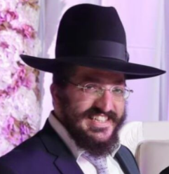

**Rabbi Shimon Matalon, z”l**

May his memory, and the memory of all the victims, be a blessing and an inspiration to us all. May their families and the entire Jewish people know no more sorrow. Amen.

*Reprinted from last week’s email of Chabad.Org Magazine.*

# Rav Avigdor Miller on

# A Woman’s Olam Haboh



**QUESTION: Do women get a separate Olam Haboh or do they share it with their husband?**

**ANSWER:** The answer is Olam Haboh is never the same for any two individuals. It’s not the same for any two individuals. Each tzadik has a canopy according to his glory, according to what he deserves. Nobody is the same in Olam Haboh.

Now the question is, women in general, will they have a lesser kind of glory than men? And the answer is certainly not. Each person has opportunities and will be rewarded exactly according to the way he or she utilizes those opportunities.  
  
**Women Have a Greater Promise then Men**

The truth is that women have a promise that men don’t have. It says Greater is the promise that Hakodosh Boruch Hu gave to women. And that means as follows: Women are not subject to the difficulties that men have – and they don’t have all the opportunities that man have.

One example: Men have opportunity, and also a drive, for more arrogance. A man has a beard; a beard makes the chin look bigger, you have to know that. A beard gives you a big chin; it makes you look more authoritative. Whereas women are humble; they more resemble young people, they more resemble children. They are more modest, more retiring than men by nature.

Everybody knows, if you have boys and girls among your children you know that the boys are the ones that you get the most Olam Haboh for raising. A woman with a lot of boys, it’s said about her that will not see the pischo shel Gehenom. She won’t see even the entrance of Gehenom because she has it already in this world.

**Raising Sons is a Big Job**

Now, I suppose it’s fun too – finally you’ll marry off all your sons and the other party will have to make the chasuna and give the dowry if you have sons. But it’s a few years till you marry them off and raising sons is a big job because sons are more pugnacious. No question about that - boys have a fighting spirit that girls don’t have.

Boys however, because of this drive, they can accomplish more than girls and that’s why they’re given more opportunities than girls outside the home.  Women are loaded down with responsibilities of a home; you can’t leave your children and run to shachris – you have to stay home and take care of the children.

And that’s their nature – Hashem gave them certain instincts that are best utilized in the home. The instinct of rachmonus, pity. The word rachamim comes from the word rechem; that’s a womanly instinct, to have pity. And also a love for children and so on. So women can become great in the sphere of her home – but they don’t have the opportunities and dangers that men have.

Men go out in a conflict. Sometimes there is a machlokes even between chachomim, between sages. And sometimes the machlokes leads to other things besides pure Torah machlokes, and there’s a big responsibility there. Shaul and Dovid were both big tzadikim but Shaul was misled to some extent by his manliness, by his desire to remain a king.

**A Certain Responsibility for Men**

He felt it was his responsibility and to a certain extent he was misled by that. The queen of Shaul and the queen of Dovid didn’t have any fights between themselves. Neither of them were pugnacious; they didn’t have the arrogance that Hakodosh Boruch Hu gave to males. So greater is the promise that is given to women.

It says Quiet daughters, daughters who are trusting. It means Hakodosh Boruch Hu said, “You can trust in Me because your reward is more guaranteed.”  
 However, men can achieve more greatness, because if they utilize their more violent natures, their drive, they can become greater. But it’s a bigger danger too.

However, in a certain sense women and men are partners in the reward of Olam Haboh. Because in addition to the first principle of each one being rewarded according to his opportunities – a woman can become great in her life just like men become great in their lives – but there is also another area where they share their reward.

And that’s when a woman is married to a man who forges ahead in serving Hashem and she serves in the background; with encouragement and he needs also a home, he needs all the wherewithal of life to enable him to continue. And certainly if she is the one to inspires him to even more effort, then surely. So therefore here is an opportunity for women to be sharers even in the achievements of men.

**The Achievements of Women**

Woman also can achieve by means of their sons or if they marry off their daughters to sons in law. It’s a greatness for women when their children, or their grandchildren, or their sons in law pursue da’as Hashem and are oisek in Torah and in mitzvos; it’s all credited to the parents, men and women.

So therefore we’ll sum up now in two ways the answer to this.

Women on their own are rewarded according to their opportunities and nobody is going to lose because he wasn’t made a man or wasn’t made a woman; each person will be rewarded according to his or her opportunities.

But in addition, there are some things that men and women share together because they are partners. Like Rabbi Akiva. When Rabbi Akiva came back after twenty four years and he became a national Torah leader, and everybody came to pay homage to him, so Rabbi Akiva said (Nedarim 50a), “My Torah and the Torah that you learnt from me, is all hers,” and he pointed to this woman Rochel, his wife whom he hadn’t seen in twenty four years. He said, “This woman is responsible for all the Torah that I have, and all the Torah that you learnt from me.”

**Rabbi Akiva’s Accomplishment was the Result of One Woman**

So now you when you look back on our history, the gemora says about Rabbi Yehuda, Rabbi Meir, Rabbi Shimon, Rabbi Elazar ben Shamua and Rabbi Yosi, that all of them were talmidim of Rabbi Akiva. And the Gemara says that all of our Torah comes from these five sages who were disciples of Rabbi Akiva. But Rabbi Akiva himself was the result, he was the creation that was brought into being by the spirit of one woman, Rochel. So here now Rochel, the wife of Rabbi Akiva, is actually the rebbe of the Jewish nation.

So it’s possible for women to attain that second form of greatness in addition to her nature and instincts and characteristics that give her opportunity to gain perfection of her own.

*Reprinted from the April 26, 2021 email of Toras Avigdor. Adapted from Tape #382.*

**Rabbi Berel Wein on**

**Parshat Bamidbar 5781**



Our Parsha begins this fourth book of the written Torah by stating that the L-rd spoke to Moshe in the desert of Sinai. In fact, this entire book takes its identity from the fact that it was spoken to Moshe and written by him while in the desert of Sinai.

A question naturally arises about the significance that all of this was taught and expounded upon in the desert of Sinai. What difference does it really make where it happened? Since there is nothing haphazard or extraneous in the Torah, it must follow that there is a lesson, a message, and insight in this detail.

This is a most foreboding venue in which to give over lessons and ideas. The Torah itself describes its harshness and difficult atmosphere – a place of serpents and scorpions, shifting sands, and theabsence of water. Is that the proper classroom in which to teach the Jewish people the eternal laws and values on the Torah? Would it not be more fitting to have a more congenial and comfortable setting, so that the listeners and students could more easily concentrate on the message and lesson being delivered? Yet, the Torah seemingly goes out of its way to emphasize that this was revealed and taught to Israel while they were wanderers in the inhospitable environment of the desert and wasteland of Sinai.

One of the lessons of teaching Torah in this difficult place is that this demonstrates that Torah is not to be limited by any specific locality or geography. If the Torah had been given in the land of Israel, then there would be a tendency to say that it only applies there, and that outside the land of Israel it is not incumbent upon the Jewish people to observe the Torah. The human mind attaches teachings to the environment and geographic location in which they are learned.

If it had been given in the land of Egypt in its entirety, before the Jewish people were free from bondage, there would be room to say that it was given only to that generation of freed slaves, but that later generations that have never experienced the lashes of the Egyptian taskmasters would not be bound to keep it. Human beings are influenced not only by lessons taught in the classroom, but also by the location of the classroom itself. By teaching the Torah in the middle of nowhere, the words, so to speak, show the features and eternity of Torah in a ‘classroom’ that is not limited by any sovereignty or appealing geographic location.

As such, the lessons remain as pristine as possible, unaffected by other outside environmental influences. It is the nothingness of the desert that is the proper backdrop, and it is the greatness and eternity of the words of the Torah that continually instruct and guide our lives and values.

*Reprinted from the current website of Rabbiwein.com*

**Rav Shlomo Wolbe, zt”l**

Rav Shlomo Wolbe, zt"l, "Rosh Bais Hamussar-Yerushalayim and renowned Mashgiach (was Mashgiach in Yeshiva Beer Yaakov) & Baal Mussar". Rav Wolbe had an interesting background. Rabbi Shlomo Wolbe (Wilhelm Wolbe, 1914 - April 25, 2005) was born in Berlin.

He was raised in a secular Jewish home and received his education at the University of Berlin (1930–1933). During his university studies he became a baal teshuva through the efforts of the Orthodox Students Union V.A.D. (Vereinigung jüdischer Akademiker in Deutschland).

After university he attended the Hildesheimer Rabbinical Seminary. He continued to study at Rabbi Boczko's yeshiva in Montreaux, Switzerland. He then attended the Mir Yeshiva in Poland, where he became a student of the mashgiach Ruchni, Rabbi Yeruchom Levovitz, and, to a lesser extent of Rabbi Yechezkel Lewvenstein.

While in the Mir, Rabbi Wolbe befriended a young man from Stockholm, Sweden, Bert Lehmann, son of Hans (Chaim) and Fannie Lehmann. During World War II, Rabbi Wolbe, who was a German national, was in danger of deportation and could not follow the Mir yeshiva into Russia and then to Shanghai.

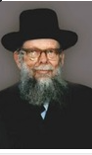

Hans Lehmann invited Rabbi Wolbe to stay with his family and be the Jewish teacher for his sons. Rabbi Wolbe thus was able to spend the war years in neutral Sweden . While he was in Sweden, he functioned there as a rabbi. During the war he worked for the US-based Rescue Committee in coordination.

At the end of the war he created a girls school for refugees in Lidingo. There, he wrote pamphlets on Judaism in Swedish and German. Rabbi Wolbe moved to Palestine in 1946 and studied at Yeshivas Lomzha. He then married Rivka Grodzinski, the daughter of Rabbi Avraham Grodzinski of the Slabodka yeshiva.

Rabbi Wolbe continued his studies at Kollel Toras Eretz Yisroel in Petach Tikva under Rabbi Yitzchok Katz. In 1948, Rabbi Wolbe took over a small yeshiva belonging to a youth organization called Ezra. Two years later, he was joined by Rabbi Moshe Shmuel Shapiro of Brisk. It is truly amazing how Rabbi Wolbe came from a secular background and became a Gadol. (Professor Yitzchok Levine) [YH: What a mussar lesson for all of us!]

*Reprinted from the Parshat Bamidbar 5781 email of whY I Matter, the parsha sheet of the Young Israel of Midwood in the Flatbush section of Brooklyn [edited by Reb Yedidye Hirtenfeld.*

*\***Parshas Bamidbar**

**Choose Your Friends Wisely**

**By Rabbi Bentzion Shafier**

**Founder of TheSmuz.com**

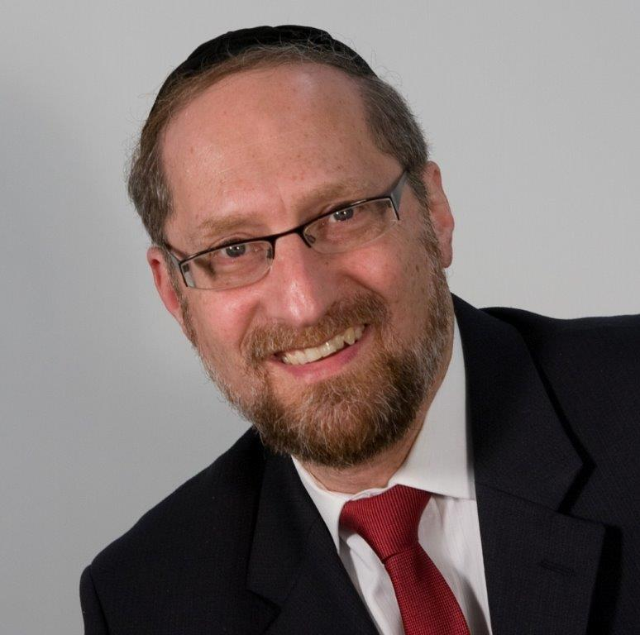

“The families of the children of Korach would encamp on the side of the Tabernacle, to the south.” — Bamidbar 3:29

**Yissochor and Zevulun became the teachers and supporters of Torah**

Rashi quotes the Medrash, “Yissochor and Zevulun became great in Torah because their tents were placed next to the tents of Moshe, Aharon, and his sons. The 250 individuals who joined Korach in his rebellion against HASHEM, on the other hand, did so because their tents were located next to Korach’s.” From here Chazal learn, **“Praise be a tzaddik, and praise be his neighbors. Woe to the rasha, and woe to his neighbors.”**

The Medrash seems to attribute both the great success of Yissochor and Zevulun as well as the utter destruction of Korach’s congregation to the influence of neighbors. This seems to imply that the pivot point for both groups was who they associated with.

What makes this statement startling is the distance between the fate of each group. Throughout the generations, the role of Torah teachers was given to Yissochor, and the role of supporting Torah went to Zevulun. In this way, they reached the heights of greatness. On the flip side, the people who followed Korach in rebellion against HASHEM are depicted as still burning in Gehinom to this day. Yet this Medrash seems to be saying that the followers of Yissochor, Zevulun, and Korach all began at the same starting point. The difference was where they dwelled.

**How could something so trivial make such a difference?**

It seems difficult to understand how such a stark difference in results could be caused simply by living in close proximity to one person. This question becomes compounded when we take into account the circumstances and the times.

**These events were taking place during the forty years in the midbar. Rather than bringing the Jewish people directly to Eretz Yisroel, HASHEM cloistered them within the confines of the Clouds of Glory. Locking them away from the world allowed them to become spiritual giants. All of their physical needs were taken care of: they ate the mon delivered to the doors of their tents; they drank water from the be’er; their clothes didn’t tatter; and their shoes didn’t wear out. They experienced countless overt miracles.**

**They had all received the Torah**

**Furthermore, all of the individuals involved had not long before stood at the foot of Har Sinai. When HASHEM proclaimed for the entire world to hear, “I am HASHEM your G-d,” every man woman and child standing there reached a level of seeing HASHEM greater than a Navi. They experienced HASHEM’s presence first-hand.**

With that experience came a clear understanding of the purpose of life. The Jews at Sinai fully recognized that we are put on the planet for a few short years with a specific mission to grow, to accomplish, and to shape ourselves into what we will be for eternity. They knew that whatever state of perfection we reach here, we will enjoy forever.

How then is it possible that something as seemingly inconsequential as living next to a tzaddik or a rasha could spell ruination or great success?

**The human: a social being**

The answer to this question seems to be that we humans are social beings, and because of this, we are exquisitely sensitive to influence from others. One of our needs is to belong. We need friendships, we crave associations, and we hunger for a sense of community. When we fit into a group that we feel a part of, we **identify** with that group. This is our chevra, our circle of friends, and it becomes almost an extension of us. Our circle of friends affects our value systems, the way we view ourselves, and our roles in all that we do. But it’s a double-edged sword. It can be one of the greatest aids to a person’s spiritual growth or the greatest liability . . .

Because the 250 men who rebelled lived in Korach’s vicinity, this became their community, their peer group. As such, it created their social environment. Korach yielded great social equity in that group, and he led the march to its abysmal failure. But those who lived in the immediate proximity of Moshe and Aharon were affected by a different force. The presence of Moshe Rabbeinu shaped the social fabric of that group. Its norms and ideals were shaped by a Torah giant. The social atmosphere had such an effect that Yissochor and Zevulun were changed for generations.

**The Power of Peer Pressure**

Chazal are teaching us that the great heights one group reached and the low depths to which the other sank were due to one factor — **peer pressure**. This is an eye-opening revelation as to the power of influence.

The average person is smarter than the average person

One of the quirks of human nature is that the average person assumes that he is smarter than the average person. Often times, when we are confronted by the foibles of human nature, we exclaim, “How strange is the human!” But we forget to take that next critical step — remembering that “**I too am a human**.”

When it comes to issues like the influence of friends, we may agree that it is significant in the lives of some, and certainly in the lives of teenagers. However, once we are fully-formed adults with a mature understanding of life and the world, we think these concepts no longer apply to us.

What we see from this Chazal is a very different perspective. The 250 men who joined Korach were men of greatness. They were distinct and illustrious, singled out by name in the beginning of Bamidbar, yet they were influenced to rebel against HASHEM. The tribes of Yissochor and Zevulun included many fully mature adults, and they became great Torah leaders, all because of the influence of others.

This is a powerful insight into the effect of the friends that we keep and their impact upon who we wish to become.

*Reprinted from the website of Theshmuz.com.*

**The Connection of the Desert**

**And the Giving of the**

**Torah to the Jewish People**

**From the Talks of the Lubavitcher Rebbe**

**Rabbi Menachem Mendel Schneerson, Zt”l**

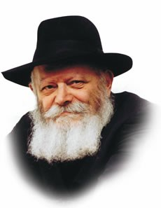

As this week's Torah portion, Bamidbar (literally "in the desert") suggests, the Torah was given to the Jewish people in an uninhabited wilderness.

A desert is a vast expanse of land to which all people have the same claim. A desert is not considered private property in the same way a house or tract of habitable land can be bought and owned by individuals.

Likewise, the Torah does not belong to any one Jew, but is the eternal inheritance and possession of all. Thus each and every Jew is able (and obligated) to study it and apply it to his daily life.

**A Place of Dust, Earth and Sand**

The desert is a place of dust, earth and sand. Vegetation cannot grow there and it is devoid of inhabitants. We too must strive to be as humble as the dust; the Torah is incompatible with haughtiness and pride. Indeed, our Sages stated, "Who is he who upholds the Torah? One who makes himself as the desert."

In the desert, the most important necessities for sustaining life are absent. There is neither water, food nor clothes. Rain does not fall, nor are there any edible plants or fruit-bearing trees. Obviously, there is no place to buy or make clothing either.

Throughout the 40 years of the Jewish people's wanderings through the desert they relied on the merit of tzadikim, righteous people, for these necessities. In Moses' merit, G-d caused the manna to fall. In the merit of Miriam, Moses' sister, a well provided them with drinking water. In the merit of Aaron, Moses' brother, G-d protected the Jews from harm with the Clouds of Glory.

**The Cleansing Power of the Clouds**

These clouds also ironed their clothes, which grew along with them and always fit perfectly.

We learn from this that when it comes to learning Torah, concerns for food, drink and clothing must play no part. Our job is to study Torah and observe its mitzvot, while relying on G-d to provide us with our needs.

Lastly, the desert is a place of great danger. Wild animals roam about freely, and snakes and scorpions lurk under rocks and inside crevices. Yet it was precisely there that G-d chose to reveal his holy Torah. Until Moshiach comes and ushers in the Final Redemption (may it happen immediately), the Jew is likewise in an extremely dangerous environment -- the exile.

The "snake," the Evil Inclination, is constantly trying to entrap him and cause him to sin. Thus it is precisely during the exile that the Jew must strive to connect himself to the Torah, and to perform its commandments to the best of his ability.

*Reprinted from the 5756/1996 Bamidbar of L’Chaim Weekly. Adapted from Likutei Sichot of the [Lubavitcher] Rebbe, Vol.1.*